Stored Procedures

Salient Features of a Stored procedure --
- Written by database developers or DBAs
- Used to perform administrative task or to apply complex business rule
- Contain DML statements
- Precompiled collection of Transact-SQL statements stored with a name

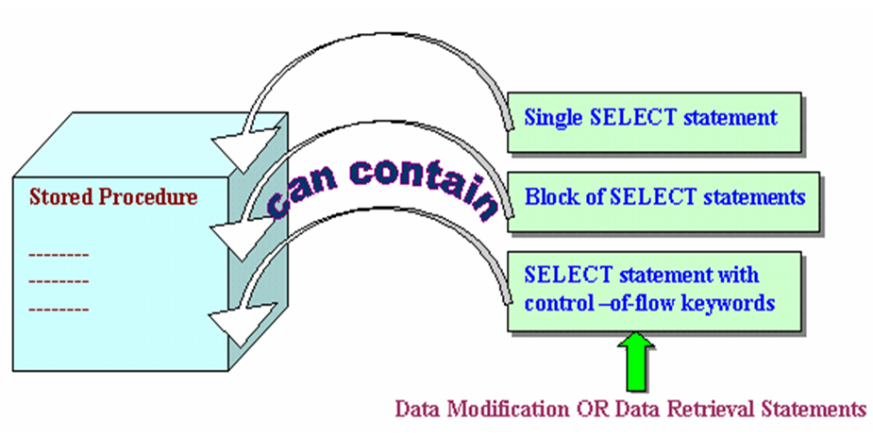

Benefits of Stored procedures –
- Speed
- Faster Access to data
- Less Compilation time
- Modular Programming
- Consistency
- Enhance the security mechanism

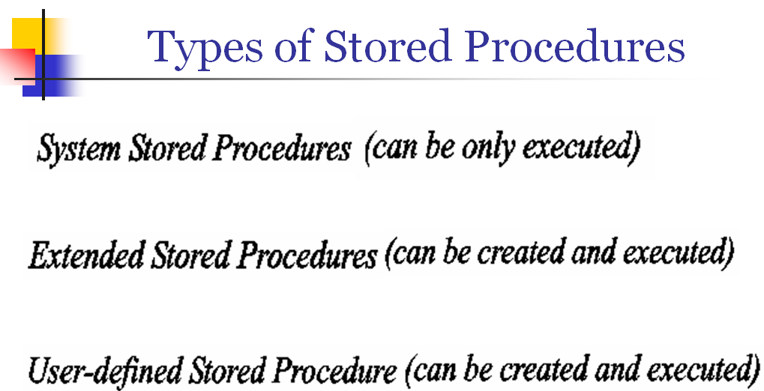

System stored procedures are grouped into the following categories
  - Catalog procedures
  - Security procedures
  - System procedures
  - Cursor procedures
  - Distributed query procedures
  - SQL Server query agent procedures
  - SQL Mail extended procedures

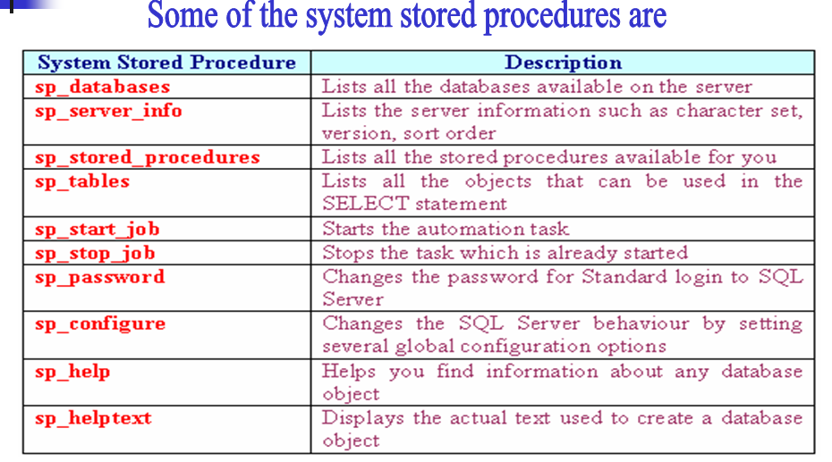
Extend SP (XP)

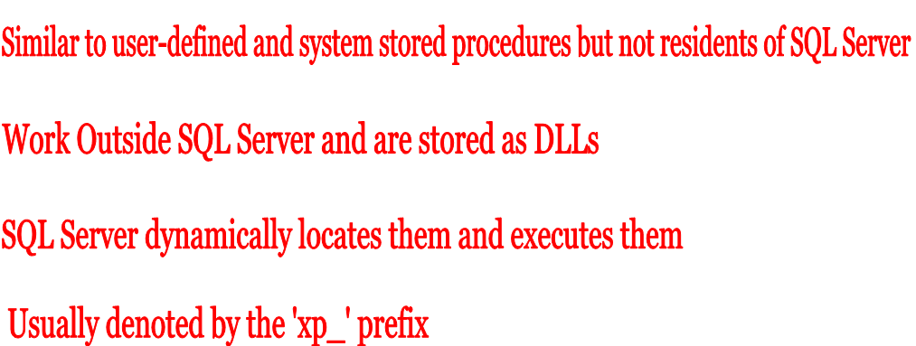

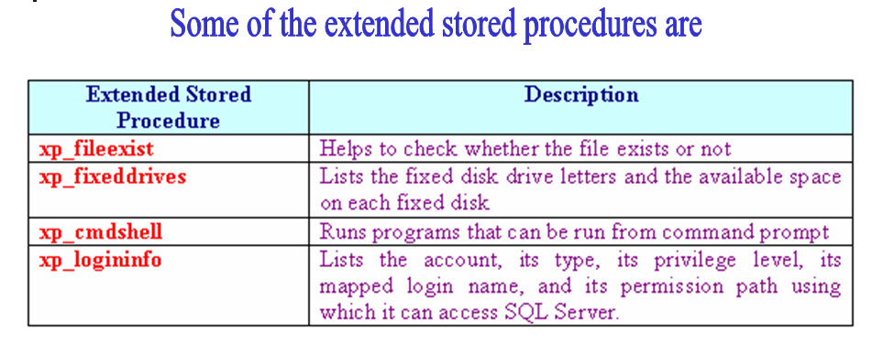

Rules for user-defined stored procedures:
  - You must select the name that follows the rules of identifier
  - Objects referred in the stored procedures must exist
  - Objects cannot be recreated with the same name in the same procedure even after you drop the procedures
  - A stored procedure can have up to 2100 parameters
  - Procedures can be nested up to 32 levels

Parameter less procedure

create procedure p1
as
select * from emp

Execute p1
OR Exec p1
OR p1

The execute clause is having no significance when the sp is getting called independently.
But if a sp is getting called inside another sp then Execute clause is mandatory.

drop procedure pr1
drop procedure pr2

drop table tab1
drop table tab2
drop table tab3

create table tab1(a int)
Insert into tab1 Values(1)
Insert into tab1 Values(2)
Insert into tab1 Values(3)
go

create table tab2(b int)
Insert into tab2 Values(4)
Insert into tab2 Values(5)
Insert into tab2 Values(6)
go

create table tab3(c int)
Insert into tab3 Values(7)
Insert into tab3 Values(8)
Insert into tab3 Values(9)
go

select * from tab1
select * from tab2
select * from tab3

create procedure pr2
as
begin
delete from tab2
end

create procedure pr1
as
begin
Delete from tab1
pr2
Delete from tab3
end

create procedure pr1
as
begin
Delete from tab1
Exec pr2 -- Calling pr2 procedure
Delete from tab3
End

exec pr1

select * from tab1
select * from tab2
select * from tab3

Procedure with parameters to create a new record

create procedure p2 (@eno integer, @name varchar(40), @dno integer)
as
insert into emp(empno,ename,deptno)
values(@eno, @name,@dno);
Print 'One record created'

Parameters can be passed by positional notation:

exec p2 123,'abc',10

Or

Parameters can be passed by named notation:

Exec p2 @eno = 456, @name = 'def', @dno = 30

Default values for the last parameter(s)

create procedure p3 @eno integer, @name varchar(40), @dno integer = 20
as
insert into emp(empno,ename,deptno)
values(@eno, @name,@dno);
Print 'One record created'

Exec p3 456,'def'

Default values for first or mid parameter(s)

create procedure p4 @eno integer, @dno integer = 30, @name varchar(50)
as
insert into emp(empno,ename,deptno)
values(@eno, @name,@dno);
Print 'One record created'

exec p4 789,default,'pqr'

Parameterized Query

create procedure p5 @j varchar(50) = 'MANAGER'
as
select * from emp
where job = @j

EXEC P5 'CLERK'

OR

EXEC P5

Output Parameter
The procedure will return value

In procedure p8 the ename will be supplied by the user as input parameter and the procedure will return the sal for that ename as the output parameter.

create procedure p8 (@name varchar(50), @salary integer output)
as
select @salary = sal
from emp
where ename = @name

To execute the procedure --

Declare a local variable.
Associate it in the parameter list of the procedure while calling the procedure.

declare @x integer
exec p8 'KING', @x OUTPUT
SELECT @x

Output Parameters can have default value:

create procedure pr2(@a int, @b int = 100 output, @c int)
as
begin
select @a
select @b
select @c
end

Exec pr2 1, default, 2

ALTER PROCEDURE Statement

Drop Table proc_tab1;
Drop Procedure show_proctab1;

create table proc_tab1(a integer);
Insert into proc_tab1 Values(1);

create procedure show_proctab1
as
select a from proc_tab1

exec show_proctab1

-- now column a of proc_tab1 table is renamed to b.

exec show_proctab1 -- Throws error

sp_helptext show_proctab1 – To get the code

alter procedure show_proctab1
as
select b from proc_tab1

exec show_proctab1 – Works properly

Imp → To change the statements or parameters in a stored procedure, you can either delete and re-create the stored procedure or alter the stored procedure in a single step. When you delete and re-create a stored procedure, all permissions associated with the stored procedure are lost. When you alter the stored procedure, the procedure or parameter definition is changed but the permissions defined for the stored procedure are retained and any dependent stored procedures or triggers are not affected.

Exception Handling:

Use Zensar_DB
go

create table transaction_data
(TrId Integer Primary Key,
TCost Int Check(TCost > 100)
)
go

create table error_data
(Serial_number int,
table_name varchar(20),
c_error_number int,
c_error_message varchar(255),
date_of_transaction date
)
go

create procedure Add_Tran(@p_TrID int, @p_TCost int)
as
begin

begin try

declare @v_serial_number int
Insert into transaction_data Values(@p_TrID , @p_TCost)

end try

begin catch
Select @v_serial_number = isNull(Max(Serial_Number),0)
from error_data

Insert into error_data
Values(
(@v_serial_number+1),
'transaction_data',
ERROR_NUMBER(),
ERROR_MESSAGE(),
getdate()
)
end catch

end
go

Insert into transaction_data Values(1,102)

Select * from error_data

Exec Add_Tran 1, 108

Select * from error_data

Exec Add_Tran 2, 99

Select * from error_data

